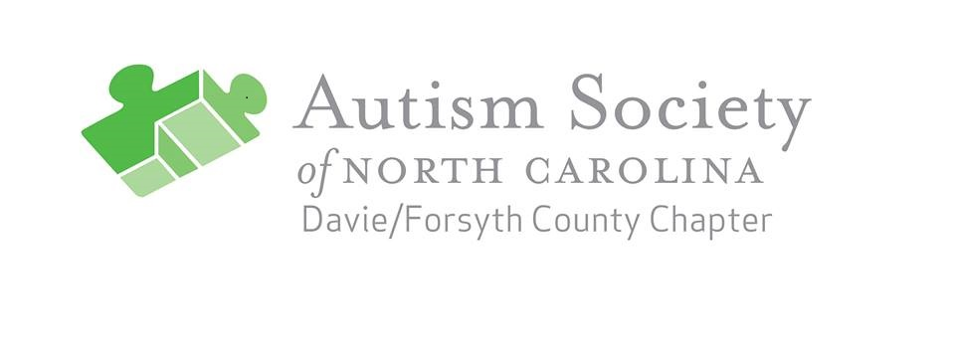 MAY ART SHOW GUIDELINES AND ENTRY FORM

The Autism Society of NC, Davie/Forsyth Chapter invites all artists living with autism to submit artworks for display during the 1st Friday Gallery Hop on Trade Street, in the Arts District in downtown Winston-Salem, on May 4, 2018, from 7-9 pm.

The artwork can focus on the exhibit themes: “What Makes Me Happy”, “Thank you to our Mothers”, or “Autism and Me”.

Eligibility/Requirements:
Eligibility: The exhibition is open to all artists with autism.
Guidelines: No works that depict nudity, sexual acts, profanity, or obscenity or that incite violence or show disrespect to any culture, religion or political viewpoint will be selected for the show. The Autism Society of NC, Davie/Forsyth Chapter reserves the right to refuse any submission that it deems unacceptable.
Entries: Each artist can submit three works of art for the show and any additional pieces which can be offered for sale as a donation to our chapter fundraiser. Additional items of artwork may submitted for sale as a fundraiser for our chapter.
Eligible Work:
Size limitations:
- 2-D artwork – maximum size 36” x 36”
- 3-D artwork – maximum size 24” tall x 24” wide.
- 3-D artwork – may weigh no more than 40 lbs.

2-D artwork may be spray mounted on rigid white paper board or framed and securely wired or on stretched canvas and securely wired. If not adequately prepared for display, artwork will not be accepted.
Art Drop-Off: Tuesday, April 24, 2018; contact davieforsythchapter@autismsociety-nc.org for info.
Art Pick up: Friday, May 4, 2018 (at end of Gallery Hop, 9 pm) Items not picked up will be donated to Downtown Arts District Association for sale.

To provide notice of participation in the Art Show, please email copy of entry form by April 20 to davieforsythchapter@autismsociety-nc.org

***************************************************************************************************

MAY ART SHOW ENTRY FORM Please submit Entry Form for each artwork.
ARTIST NAME
SCHOOL
CONTACT INFO: PHONE
ADDRESS
TITLE OF ARTWORK
Available for sale? Price?

